Task 1: Data Analytics Tools Setup and Introduction
Introduction
My name is Kashaf Fatima, and I am a Final Year student of Information Technology at the University of Sindh, Jamshoro. I have a strong interest in data analytics, business intelligence, and data driven decision making. As technology continues to transform industries, the ability to analyze and interpret data has become an essential skill for professionals in every field.
I am currently participating in the CoreTech Data Analytics Internship Program to develop practical knowledge and hands on experience in modern data analytics tools and techniques. Through this internship, I aim to enhance my analytical skills, learn how to work with real world data, and gain expertise in tools such as Microsoft Excel, Google Sheets, Power BI, SQL, and other data analytics technologies.
I am excited to begin this learning journey and look forward to applying data analytics concepts to solve real world business problems and support informed decision making.

1. What is Data Analytics?
Data Analytics is the process of collecting, organizing, cleaning, transforming, and analyzing data to discover useful information, identify patterns, and generate meaningful insights. Organizations collect large amounts of data every day from customers, operations, websites, applications, and business activities. Data Analytics helps convert this raw data into valuable knowledge that can support decision-making and improve business performance.
The main purpose of data analytics is to understand what has happened, why it happened, what is likely to happen in the future, and what actions should be taken. By analyzing data, organizations can improve efficiency, reduce costs, increase profitability, understand customer behavior, and make informed strategic decisions.
In today's digital world, Data Analytics has become an essential part of almost every industry, including business, healthcare, education, finance, marketing, and technology. It enables organizations to make decisions based on facts and evidence rather than assumptions.

2. What Does a Data Analyst Do?
A Data Analyst is a professional who collects, processes, analyzes, and interprets data to help organizations solve problems and make better decisions. Data Analysts work with large datasets and transform complex information into meaningful insights that can be easily understood by managers, stakeholders, and decision-makers.
The key responsibilities of a Data Analyst include:
- Collecting data from various sources such as databases, surveys, websites, and business systems.
- Cleaning and preparing data by removing errors, duplicates, and inconsistencies.
- Organizing and managing datasets for analysis.
- Analyzing data to identify trends, patterns, and relationships.
- Creating reports, charts, dashboards, and visualizations.
- Interpreting findings and presenting recommendations.
- Supporting business decisions with accurate and reliable information.
- Monitoring key performance indicators (KPIs) and business metrics.
A Data Analyst acts as a bridge between raw data and business decision-making by transforming data into actionable insights that help organizations achieve their goals.
3. Difference Between Data, Information, and Insight
Although Data, Information, and Insight are closely related, they have different meanings and purposes.
Data
Data consists of raw facts, figures, observations, or records that have not yet been processed or analyzed. By itself, data may not provide any meaningful understanding.
Example:
- Sales on Monday: 120 units
- Sales on Tuesday: 150 units
- Sales on Wednesday: 180 units
These numbers alone represent raw data.

Information
Information is created when data is processed, organized, and presented in a meaningful way. Information helps people understand what is happening.
Example:
A monthly report showing that total sales increased by 20% compared to the previous month.
This organized summary is information.
Insight
Insight is a deeper understanding or conclusion obtained from analyzing information. Insights help organizations make decisions and take action.
Example:
Analysis reveals that sales increase significantly during promotional campaigns and weekends. Based on this insight, the company can plan more promotions during those periods.
Summary
Term | Meaning | Example
Data | Raw facts and figures | Daily sales numbers
Information | Processed and organized data | Monthly sales report
Insight | Actionable conclusion from information | Sales are highest during promotions
Understanding the difference between these three concepts is essential because data analytics focuses on transforming raw data into valuable insights that support business success.

4. How Analytics Helps CoreTech Innovation
Data Analytics can play a significant role in helping CoreTech Innovation improve its business operations, increase efficiency, and make strategic decisions. In today's competitive environment, organizations need accurate information to understand customer needs, evaluate performance, and identify opportunities for growth.
Analytics can help CoreTech Innovation in the following ways:
Better Decision Making
Analytics provides accurate and reliable information that helps management make informed decisions based on facts rather than assumptions.
Understanding Customer Behavior
By analyzing customer data, the company can understand customer preferences, interests, and purchasing behavior. This helps improve products and services.
Performance Monitoring
Analytics allows organizations to track key performance indicators (KPIs), monitor progress, and evaluate whether business objectives are being achieved.
Identifying Trends and Opportunities
Data analysis helps identify market trends, customer demands, and business opportunities that can support growth and innovation.
Improving Operational Efficiency
Analytics can reveal inefficiencies, bottlenecks, and areas that require improvement, helping the organization reduce costs and optimize resources.
Risk Management
Through predictive analysis and data monitoring, potential risks can be identified early, allowing the company to take preventive actions.
Dashboard and Reporting
Tools such as Power BI can create interactive dashboards and reports that provide real-time business insights and improve communication among stakeholders.
By utilizing data analytics effectively, CoreTech Innovation can improve productivity, enhance customer satisfaction, strengthen decision-making, and gain a competitive advantage in the market.

5. Which Tools Are Used in Data Analytics?
Data Analysts use a variety of tools to collect, manage, analyze, visualize, and report data. Some of the most commonly used tools include:
Microsoft Excel
Microsoft Excel is one of the most widely used tools for data entry, data cleaning, calculations, data analysis, and reporting. It provides features such as formulas, functions, Pivot Tables, and charts.
Google Sheets
Google Sheets is a cloud-based spreadsheet application that allows users to work collaboratively, manage data, and perform basic analysis from anywhere with internet access.
Power BI
Power BI is a powerful Business Intelligence (BI) tool developed by Microsoft. It is used to create interactive dashboards, visual reports, and business performance analytics.
SQL (Structured Query Language)
SQL is used to access, retrieve, manage, and analyze data stored in databases. It is an essential skill for Data Analysts working with large datasets.
Python
Python is a popular programming language used for data analysis, automation, statistical analysis, machine learning, and data visualization.
Tableau
Tableau is a leading data visualization tool that helps organizations create interactive charts, dashboards, and reports for better decision-making.

Google Drive
Google Drive is used to store, organize, share, and collaborate on datasets, reports, and analytics projects in a secure cloud environment.
Other Tools
Data Analysts may also use:
- Microsoft Power Query
- Microsoft Power Pivot
- R Programming
- Looker Studio
- Jupyter Notebook
- Microsoft SQL Server
These tools enable Data Analysts to efficiently process data, generate insights, create visualizations, and support data-driven decision-making within organizations.
SETUP SCREENSHOT:
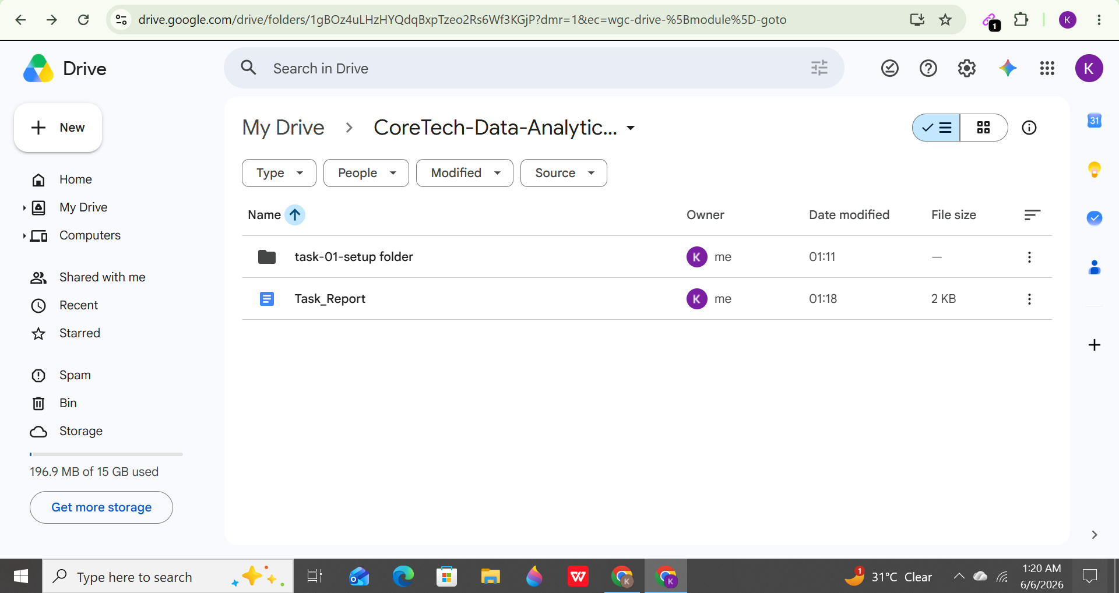

POWER BI SCREENSHOT:
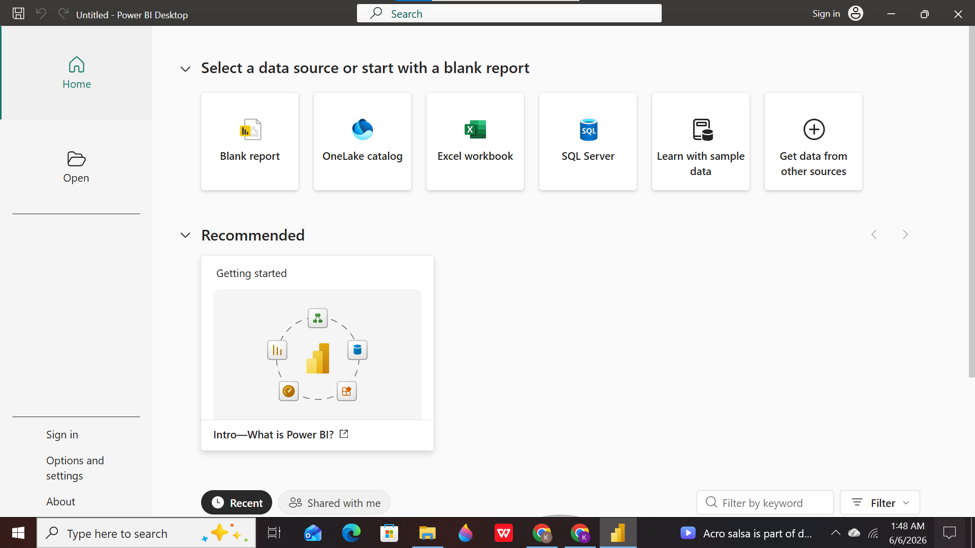

GOOGLE SHEET SCREENSHOT:
